**ET 9823BQ photomultiplier base modification for use in Hall B Cherenkov detector.**

Pictures of manufactured PCBs installed on the top of the standard tube base.

A 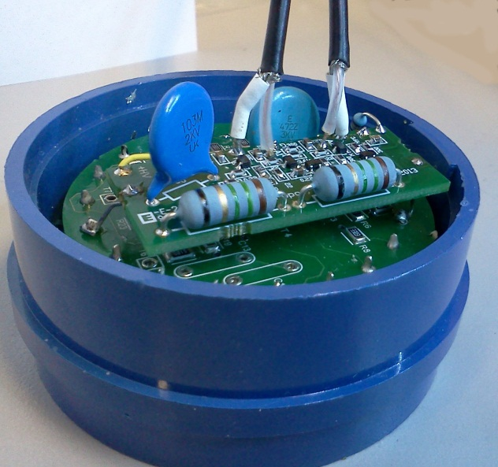 B 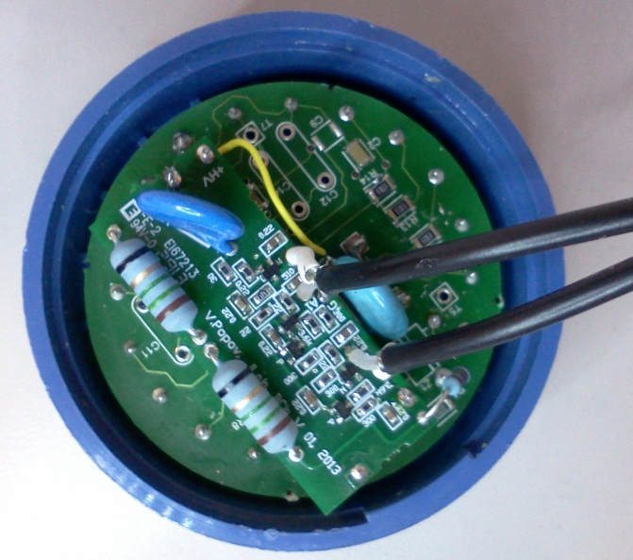

C 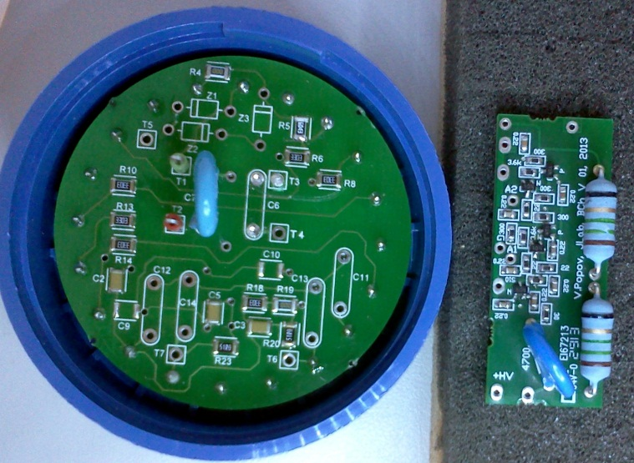 Fig. 1 Photos of PCB and bases with installed PCB-amplifier.

PCBs were manufactured and tested. Five boards are stuffed with components and installed on the top of regular PMT base. No errors were found.The amplifier gain is reduced to about 8 factor, and need final optimization after testing. The divider is modified, and modification is performed from the open side and may be reversed if require. The new division chain provides 30% higher voltage on the focusing electrode and on the first dynode.

Fig. 2 shows a sample of low light pulses obtained with fast LED light source at 1.6 kV PMT bias voltage.

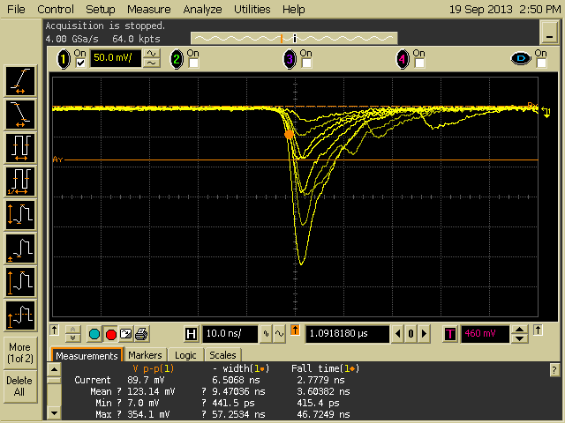

Fig. 2 Image of output pulses from 9823BQ tube installed in the new active base. HV=1.6 kV

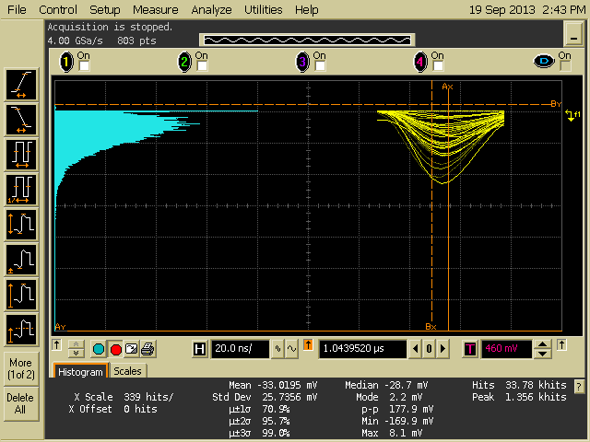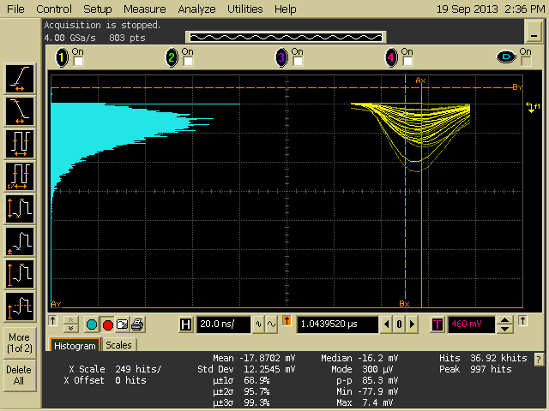

Fig. 3 Single electron PHD histograms obtained with LED source operated at 1 kHz rate. 35ns shaping time digital filter is used in histograms. Left-PMT HV=1.6 kV; Right-PMT HV=1.5kV.

Five PCB boards are stuffed with component and prepared for testing (two were initially tested).